
RAMAIAH
Institute of Technology
USN | 1 | M | S

(Autonomous Institute, Affiliated to VTU)
(Approved by AICTE, New Delhi & Govt. of Karnataka) Accredited by NBA & NAAC with ‘A’ Grade

SEMESTER END EXAMINATIONS – MAY/JUNE 2018

Course & Branch | : | B.E. : Information Science and  Engineering | Semester | : | IV
Subject | : | Design and Analysis of Algorithms | Max. Marks | : | 100
Subject Code | : | IS44 | Duration | : | 3 Hrs

Instructions to the Candidates:
- Answer one full question from each unit.

 |  |  | UNIT – I
1. | a) |  | Define the following notations (formal definition) O, Θ and Ω with an example for each. | CO1 | (06)
 | b) |  | Design an algorithm (with linear order of growth) for computing the value of a polynomial p(x) = a_{n}x^{n} + a_{n-1}x^{n-1} +….+a₁x+a₀ at a given point x₀. | CO1 | (06)
 | c) |  | Summarize the general plan for analyzing recursive algorithms. Develop a recursive algorithm to find the number of binary digits in the binary representation of a positive decimal integer, and analyze the complexity of the algorithm. | CO1 | (08)
2 | a) |  | Solve the following recurrence relation:  i. x(n) = x(n/2)+n for n>1, x(1) =1 (solve for n=2^{k})  ii. x(n) = 4x(n-1) for n>1, x(1) = 5  iii. x(n) = x(n-1)+6 for n>1, x(1) = 0. | CO1 | (06)
 | b) |  | Write a recursive algorithm to compute the sum of first n cubes: S(n) = 1³+2³+…+n³. Set up and solve a recurrence relation for the number of times algorithm’s basic operation is executed. | CO1 | (06)
 | c) |  | Summarize the general plan for analysing non-recursive algorithms. Develop a non-recursive algorithm for element uniqueness problem and analyze the complexity of the algorithm. | CO1 | (08)
 |  |  | UNIT – II
3. | a) |  | Develop an algorithm to sort the given set of characters in alphabetical order using bubble sort technique and analyze its efficiency. | CO2 | (06)
 | b) |  | Construct a shift table for the pattern REORDER, and search for the same in the text THERE-IS-AN-ORDER-AND-WE-ARE-REORDERING-IT using Horspool’s matching algorithm. Find the number of comparisons made in each iteration of the algorithm. | CO2 | (06)
 | c) |  | Develop an algorithm for sorting an array of integers using Quick sort technique. Apply quick sort for the input {26,58,29,46,109,87,49,60}. Analyze the efficiency of Quick sort algorithm. | CO2 | (08)
4. | a) |  | Design an algorithm for sorting elements of an array in the decreasing order using Selection sort technique. Also analyse worst-case efficiency of the algorithm. | CO2 | (06)
 | b) |  | Design a recursive algorithm for computing the height of a binary tree. Find the number of recursive calls made. | CO2 | (06)
 | c) |  | Develop an algorithm for sorting elements of an array using the Merge Sort technique. Draw the tree structure of the recursive calls made for the input {25, 57, 8, 41, 72, 1, 90, 33, 13}. Analyze the efficiency of Merge sort algorithm. | CO2 | (08)
 |  |  | UNIT – III
5. | a) |  | Apply Warshall’s algorithm for the graph defined by following adjacency matrix and compute transitive closure. | CO3 | (06)
  0 | 1 | 0 | 0 | 0
  0 | 1 | 1 | 0 | 0
  0 | 0 | 0 | 0 | 1
  0 | 0 | 1 | 0 | 0
  0 | 0 | 0 | 1 | 0
 | b) |  | Write Kruskal’s algorithm to find minimum spanning tree and apply for the following graph also show the result after each step of the algorithm.  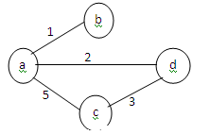 | CO3 | (06)
 | c) |  | Solve the all-pairs shortest-path problem for the digraph with the weight matrix. Using final distance matrix write the corresponding graph.  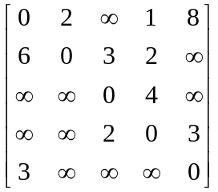 | CO3 | (08)
6. | a) |  | Apply the bottom-up dynamic programming algorithm to the following instance of knapsack problem (capacity = 10). Find optimal solution indicate the entries in the dynamic programming table. Also find the subset of objects in the knapsack. | CO3 | (06)
  Item | Weight | Profit
  1 | 7 | 42
  2 | 3 | 12
  3 | 4 | 40
  4 | 5 | 25
 | b) |  | For the following graph, solve the single source shortest path problem with vertex “ a “ as the source.  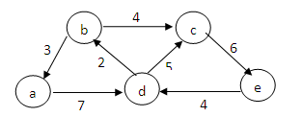 | CO3 | (06)
 | c) |  | What is Greedy Technique? Write Prim’s algorithm to find minimum spanning tree of a given graph. Apply Prim’s algorithm and find minimum spanning tree for the given graph.  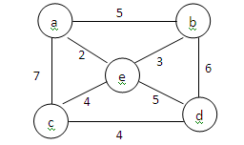 | CO3 | (08)
 |  |  | UNIT- IV
7. | a) |  | Apply decrease by one design technique to develop an algorithm to sort the given list of elements in descending order. Find best case, worst case and average case performance of the algorithm developed. | CO4 | (06)
 | b) |  | Develop pseudo code for the divide-into-three algorithm for fake-coin problem. | CO4 | (06)
 | c) |  | Develop an algorithm to perform DFS traversal on a graph G=<V,E>. For the graph given below perform DFS traversal with ‘a’ as the starting vertex, write DFS forest, push and pop order of vertices .  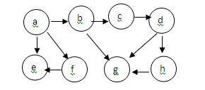 | CO4 | (08)
8. | a) |  | Develop a recursive algorithm to solve Josephus problem. Analyze its efficiency. | CO4 | (06)
 | b) |  | For the following graph list the topological ordering of the vertices using source removal algorithm.  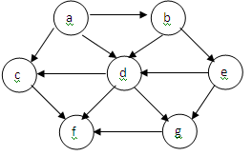 | CO4 | (06)
 | c) |  | Illustrate four rotations applied on AVL trees. Given the following set of elements, construct an AVL tree by inserting elements successively starting with an empty tree: 3,6,5,1,2,4,12,14 | CO4 | (08)
 |  |  | UNIT - V
9. |  | a) | Define Heap. Elaborate on various properties of heap. | CO5 | (06)
 |  | b) | What is branch-and-bound technique? Explain the cases in which a search path at a node on a state space tree of branch-and-bound algorithm is terminated. | CO5 | (06)
 |  | c) | What is backtracking? Construct state space tree for solving the four queen’s problem by back tracking. | CO5 | (08)
10. |  | a) | Draw decision trees for the following:  - three element insertion sort  (ii) binary decision tree for binary search in a four-element array. | CO5 | (06)
 |  | b) | Define P, NP and NP complete problems with examples. | CO5 | (06)
 |  | c) | Develop an algorithm to construct a heap using bottom-up approach. Apply heap sort algorithm to sort the following set of elements in ascending order. Show the status of the array after each step: 5, 3,1,9,8,2,4,7. | CO5 | (08)

****************

